**PROJECT DEVELOPMENT PHASE**-**SPRINT-1**

**IOT DEVICE**

|  |  |
| --- | --- |
| Date | 13 November 2022 |
| Team ID | PNT2022TMID12733 |
| Project Name | IoT Based Safety Gadget for Child Safety Monitoring and Notification |
| Maximum Marks | 1. Marks |

**AIM:**

To get the coordinates of the child using GPS & ESP32

**HARDWARE REQUIRED:**

* ESP32-WROOM-32U
* [NEO-6M GPS Module](https://robu.in/product/ublox-neo-6m-gps-module/)
* Micro-USB Cable
* Connecting wires

**SOFTWARE REQUIRED:**

* Arduino IDE to run the program

**CIRCUIT DIAGRAM:**

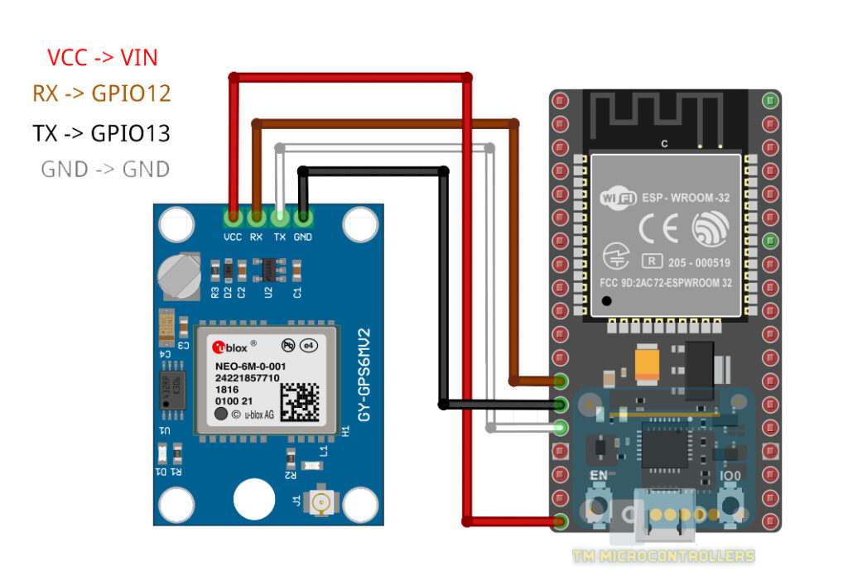

|  |  |
| --- | --- |
| **ESP32 board** | **NEO-6M Module** |
| VCC = 5V | VCC |
| RX0 | TX |
| TX0 | RX |
| GND | GND |

**PIN CONNECTION:**

**WIRE CONNECTION:**

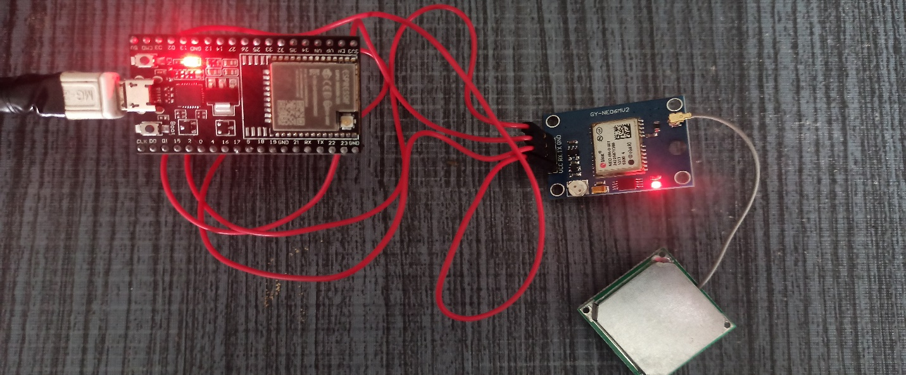

**SOURCE CODE FOR COORDINATES:**

#include <TinyGPSPlus.h>

TinyGPSPlus gps;

void setup()

{

Serial.begin(9600);

Serial2.begin(9600);

delay(3000);

}

void loop()

{

while (Serial2.available() > 0)

if (gps.encode(Serial2.read()))

displayInfo();

if (millis() > 5000 && gps.charsProcessed() < 10)

{

Serial.println(F("No GPS detected: check wiring."));

while (true);

}

}

void displayInfo()

{

Serial.print(F("Location: "));

if (gps.location.isValid())

{

Serial.print("Lat: ");

Serial.print(gps.location.lat(), 6);

Serial.print(F(","));

Serial.print("Lng: ");

Serial.print(gps.location.lng(), 6);

Serial.println();

}

else

{

Serial.print(F("INVALID"));

}

}

void updateSerial()

{

delay(500);

while (Serial.available())

{

Serial2.write(Serial.read());//Forward what Serial received to Software Serial Port

}

while (Serial2.available())

{

Serial.write(Serial2.read());//Forward what Software Serial received to Serial Port

}

}

**Output:**

